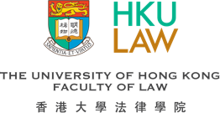

HKU Rule of Law Education Project – Rule of Law Essay Competition 2023
香港大學法治教育計劃 – 法治徵文比賽2023
Application Form 報名表格
Participant’s Name
參賽者姓名

Name of School
學校名稱

Form
年級

Contact Number
聯絡電話

Email Address
電郵地址

Declaration 聲明
I hereby declare that我謹在此聲明:
- I have studied the rules of the competition, and I will be bound by all of the requirements.
我已閱讀比賽規則，並同意遵守所有比賽要求。
- The details furnished above are true and correct to the best of my knowledge and belief and I undertake to inform you of any changes therein, immediately.
據我的所知所信，以上的資料均屬正確，如以上資料有所變更，我將立刻予以通知。
- The work I submitted is my original work, does not contain any plagiarism, and has not been published in any form.
我所提交的作品為個人原創，沒有任何抄襲成份，而且未曾以任何形式公開發表。
- I have not used generative AI (artificial intelligence) in my submission.
我所提交的作品沒有使用人工智能生成工具。

Signature簽署: __________________________________
Date日期: ______________________________________

